# SAD Document - Process View

The goal of a process view is to visually represent the critical scenarios as a sequence of events through the use of UML Activity Diagrams. These events include both user and system operations, and can contain conditional paths that lead to situational events. The critical scenarios of the room reservation system are as follows:

1. Logging in to the system (Figure 1)
2. Creating a reservation (Figure 2)
3. Cancelling a reservation (Figure 3)
4. Modifying a reservation (Figure 4)
5. Changing profile details (Figure 5)

**Figure 1 - Authentication**

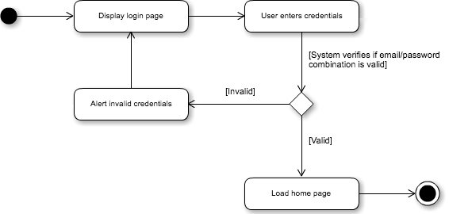

This activity diagram represents the path for logging into the room reservation system. When the site is first accessed, the user will be greeted with a login page where they are prompted to enter their credentials (email address and password). The user enters their credentials, after which the system verifies the database to ensure that the credentials correspond to an existing account. If the credentials are valid, then the user is logged in and redirected to the site’s home page. On the other hand, if the credentials are invalid, then a message will appear to inform the user, after which they will be prompted to enter their credentials again.

**Figure 2 - Creating a Reservation**

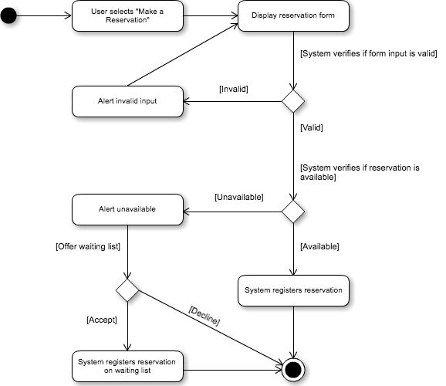

This activity diagram represents the path for creating an available reservation or creating a reservation in the waiting list. On the home page, the user selects “Make a Reservation” from the toolbar. A form with all required information will appear, in which the user must define a title, description, start time/date, end time/date, and room. First, the system verifies if these inputs are valid. Examples of invalid inputs would be any blank field, or one that surpasses the character limit. If the input if invalid, then the user will be informed and told to try again.

Next, the system verifies if the selected time/date/room combination is available, or if the user already has 3 existing reservations for that week. If the combination is available, then the system registers the reservation associated with the student. However, if it is unavailable, the system alerts the user and offers to place this reservation on the waiting list. If the user accepts, then the system registers the reservation associated with the student and notes that it is waitlisted. If the user declines, then the reservation process is cancelled entirely.

**Figure 3 - Cancel Reservation**

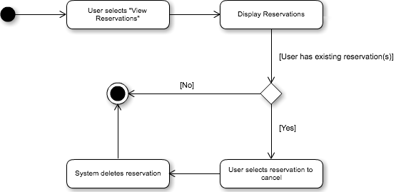

This activity diagram represents the path for cancelling an existing reservation associated with the authenticated user. First, the user must select “View Reservations” from the toolbar. The system will display all existing reservations, providing the option to cancel them. Evidently, if the user has no existing reservations, this option will not be displayed. If the user selects a reservation to cancel, then it will be removed from the system and disassociated from the user.

**Figure 4 - Modify Reservation**

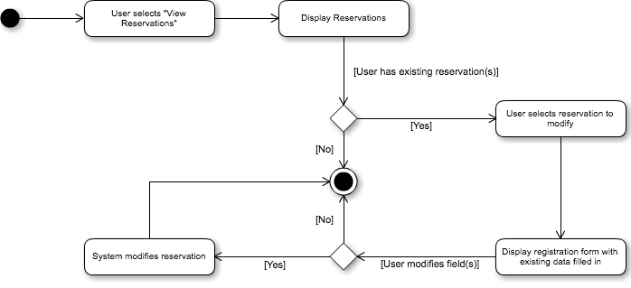

This activity diagram represents the path for modifying an existing reservation associated with the authenticated user. First, the user must select “View Reservations” from the toolbar. The system will display all existing reservations, providing the option to modify them. Evidently, if the user has no existing reservations, this option will not be displayed.

If the user selects a reservation to modify, then a form will appear with all the reservation information fields filled in. These fields are all modifiable, so the user can change any information as required. If no fields are modified, then the existing reservation is left alone. If any fields are modified, then the new reservation information replaces the respective old one in the system.

**Figure 5 - Change Profile Details**

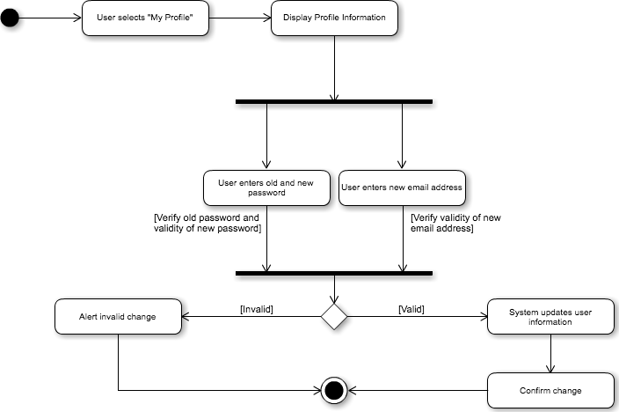

This activity diagram represents the path for changing the authenticated user’s profile information. The information that could be changed is limited to the email and password, since the student information is permanent in the student record. The user must first select “My Profile” from the toolbar. The user’s information is then displayed, with the email and password fields being modifiable. The user can then change either of the aforementioned, or both.

If the user wishes to change their password, then they must enter their old password and new password in those respective fields, and then press submit. The system then verifies if the inputted passwords are valid. That is, if the old password field matches the current one, and if the new password field contains a valid string.

If the user wishes to change their email, then they must simply enter their desired email address in the new email address field, and press submit. The system then verifies if the inputted email address is valid.

If all is valid, then the system updates the user information associated with the authenticated user. If the form input is invalid, then the user is alerted of their error, and no change is made in the system.